03/15/2024
To collect 1000 samples or more, I prefer to get smaller sets of samples, like 50-100 samples per run at a time, and repeat this process multiple times (Kasi laptop gamit ko, masyadong matagal kung 1000 samples agad per run ng bootstrap.py huhu). It will append the parameters.txt naman.

03/22/2024
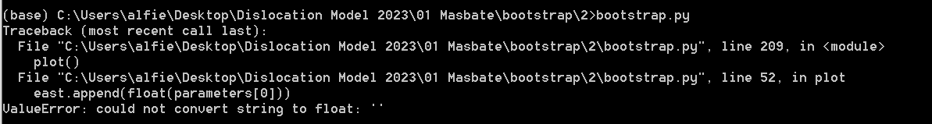
If you encounter this error, just delete the empty lines e.g. 1001-1002
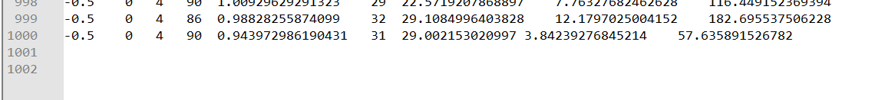

05/13/2024
- Matlab R2020b requires python <3.8.0 https://www.mathworks.com/support/requirements/python-compatibility.html
https://pypi.org/project/matlabengine/#history
- Need the modules “matlabengine”, “matplotlib” and pandas”
  - e.g. python -m pip install matlabengine==9.9.1
- Install MATLAB Engine API for Python
  - Change directory to matlab C:\Program Files\MATLAB\R2020b\extern\engines\python then run “python setup.py install”
  - To check if “matlab engine for python” is installed, run “pip list”
    - https://www.mathworks.com/help/matlab/matlab_external/install-the-matlab-engine-for-python.html
    - https://www.mathworks.com/matlabcentral/answers/1631805-fail-to-install-matlab-r2021b-in-python-3-8-3-9-setuptools-error-pep-440

05/14/2024
- Modified the first script to fix the issues mentioned below
- USE VERSION 2 if encountered these problems “ModuleNotFound: Matlab” and ‘AttributeError: 'DataFrame' object has no attribute 'append'
- Python script should be able to run in CMD (if not using other platforms such as conda)

05/15/2024
- Header titles “E_coord” and “N_coord” changed to “Ecoord” and “Ncoord” because it messes up append/concat

06/13/2024
- Will improve the script soon
  - Remove empty files
  - Add user input

-CJVC

